**Assignment 1**

**Task 1:**

Write a simple console application with main method and use at least 2 different types of relational operators, 3 bitwise operators and all types of logical operators shown in the lecture slides.

***Description:*** In this code, I’ve taken two subject marks and test them with mentioned operators.

***Code:***

public class task {

public static void main(String args[]) {

/* relational operators '==' and '>=' */

int englishMarks=80, mathsMarks=60;

++englishMarks; //including '1' gracemarks

if(englishMarks>=80){ // greater than or equal to operator

System.out.println("Marks are " + englishMarks + " and Grade is 'A'");

}

if(mathsMarks==60){ //equal to operator

System.out.println("Marks are " + mathsMarks + " and Grade is 'C'");

}

/* bitwise operators '^' , '|' and ‘~’ */

System.out.println("englishMarks ^ mathsMarks = " + (englishMarks^mathsMarks)); // bitwise XOR

System.out.println("englishMarks | mathsMarks = " + (englishMarks|mathsMarks)); // bitwise OR

System.out.println("~englishMarks = " + (~englishMarks)); // bitwise compliment

/* Logical Operators '&&' and '||' */

if(englishMarks==80 || englishMarks>80){

System.out.println("English Passed Succesfully!!");

}

if(mathsMarks==60 && mathsMarks>59){

System.out.println("Maths Passed Succesfully!!");

}

}

}

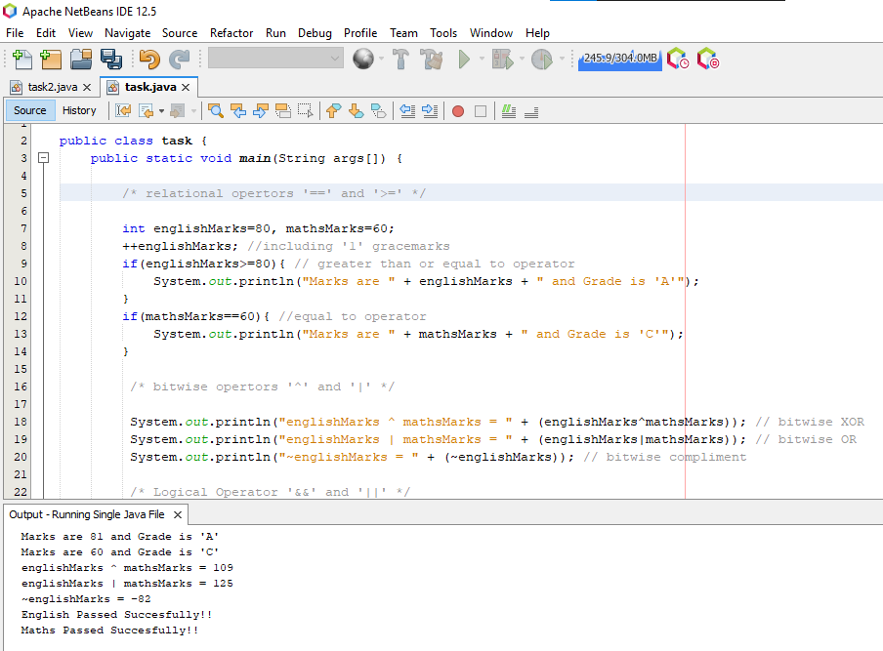

**Task 2:**

Dry run the following snippet of code and write output of each statement in front of the statement. You don’t need to run it.

public static void main (String[] args){

int i = 3, k = 1;

i++; *//first the operation is performed (i=3) and then post increment occurs*

System.out.println(i); *// ‘****4’*** *will be printed on console screen.*

++i; *// first pre-increment occurs(i=5)*

System.out.println(i); *// ‘****5’*** *will be printed on console screen*

System.out.println(++i); *//value is pre-incremented first🡪(i=6),* ***6*** *printed on screen*

System.out.println(i++); *//first operation is performed🡪(i=6), ‘****6’*** *printed on screen*

System.out.println(++i); *//now i=7, value is pre-incremented first🡪 (i=8),****’8’*** *printed operation is performed*

k = ++i - i++; *//9-9=0, k=0*

System.out.println(k++); *//first operation is performed (k=0) and ‘****0’*** *will be printed on screen, then post-increment occurs🡪(k=1)*

}

**Task 3:**

Draw the following pattern using loops and conditions.

* *  
** **  
*** ***  
**** ****  
***** *****  
****** ******  
******* *******  
******** ********

***Description:*** 3 loops are used. Outer loop is used for 20 iterations starting from 2 with increment of 2. Two inner loops are used for dividing the pattern into two sections with spacing in between.

***Code:***

public static void main(String args[]) {

for(int x=2;x<20;x+=2)

{

for(int i=0;i<x/2;i++) //loop for displaying left pyramids before spacing

{

System.out.print("*");

}

System.out.print(" "); // for spacing between two pyramids

for(int i=0;i<x/2;i++) //loop for displaying right pyramids after spacing

{

System.out.print("*");

}

System.out.print("\n"); // for end of line in each iteration

}

}

}

